1 run......

training 1 epoch...

52.75287652015686 seconds used......

1 training finished! average train loss: 0.7248651278446395

evaluating...

Confusion matrix, without normalization

[[ 206 24 543]

[ 47 65 318]

[ 44 8 2277]]

Normalized confusion matrix

[[0.26649418 0.03104787 0.70245796]

[0.10930233 0.15116279 0.73953488]

[0.01889223 0.00343495 0.97767282]]

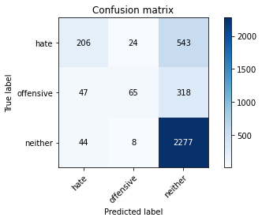

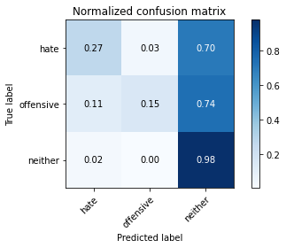

precision recall f1-score support

hate 0.69 0.27 0.39 773

offensive 0.67 0.15 0.25 430

neither 0.73 0.98 0.83 2329

accuracy 0.72 3532

macro avg 0.70 0.47 0.49 3532

weighted avg 0.71 0.72 0.66 3532

average eval_loss: 0.7265083469913505, accuracy: 0.7214043035107588

training 2 epoch...

52.74016618728638 seconds used......

2 training finished! average train loss: 0.49565219472485234

evaluating...

Confusion matrix, without normalization

[[ 306 90 377]

[ 52 162 216]

[ 101 71 2157]]

Normalized confusion matrix

[[0.39586028 0.1164295 0.48771022]

[0.12093023 0.37674419 0.50232558]

[0.04336625 0.03048519 0.92614856]]

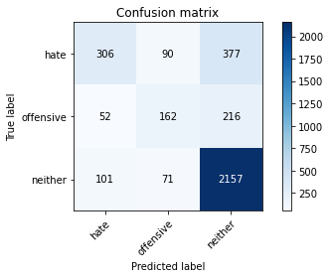

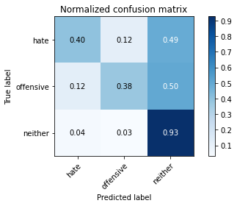

precision recall f1-score support

hate 0.67 0.40 0.50 773

offensive 0.50 0.38 0.43 430

neither 0.78 0.93 0.85 2329

accuracy 0.74 3532

macro avg 0.65 0.57 0.59 3532

weighted avg 0.72 0.74 0.72 3532

average eval_loss: 0.6829539860709238, accuracy: 0.7432049830124575

training 3 epoch...

52.75212049484253 seconds used......

3 training finished! average train loss: 0.3048806503875203

evaluating...

Confusion matrix, without normalization

[[ 289 109 375]

[ 52 181 197]

[ 103 86 2140]]

Normalized confusion matrix

[[0.37386805 0.14100906 0.4851229 ]

[0.12093023 0.42093023 0.45813953]

[0.04422499 0.03692572 0.91884929]]

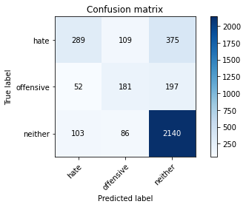

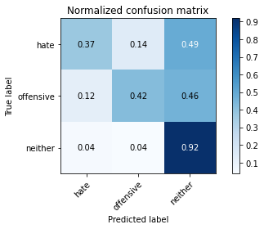

precision recall f1-score support

hate 0.65 0.37 0.47 773

offensive 0.48 0.42 0.45 430

neither 0.79 0.92 0.85 2329

accuracy 0.74 3532

macro avg 0.64 0.57 0.59 3532

weighted avg 0.72 0.74 0.72 3532

average eval_loss: 0.7959530454150028, accuracy: 0.7389580973952435

training 4 epoch...

52.752573013305664 seconds used......

4 training finished! average train loss: 0.1400746157860376

evaluating...

Confusion matrix, without normalization

[[ 320 76 377]

[ 75 144 211]

[ 116 61 2152]]

Normalized confusion matrix

[[0.41397154 0.09831824 0.48771022]

[0.1744186 0.33488372 0.49069767]

[0.04980678 0.0261915 0.92400172]]

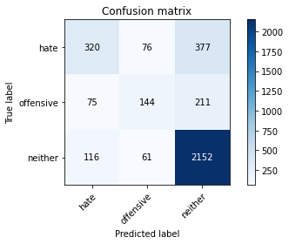

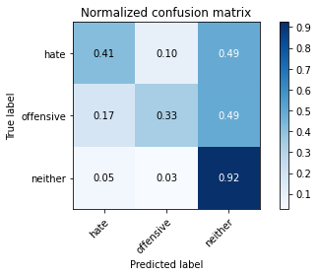

precision recall f1-score support

hate 0.63 0.41 0.50 773

offensive 0.51 0.33 0.41 430

neither 0.79 0.92 0.85 2329

accuracy 0.74 3532

macro avg 0.64 0.56 0.58 3532

weighted avg 0.72 0.74 0.72 3532

average eval_loss: 1.0289414024959176, accuracy: 0.7406568516421291

training 5 epoch...

52.80733394622803 seconds used......

5 training finished! average train loss: 0.057318078662895885

evaluating...

Confusion matrix, without normalization

[[ 311 99 363]

[ 72 174 184]

[ 117 108 2104]]

Normalized confusion matrix

[[0.40232859 0.12807245 0.46959897]

[0.16744186 0.40465116 0.42790698]

[0.05023615 0.04637183 0.90339201]]

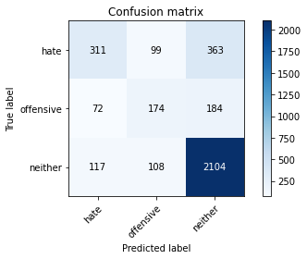

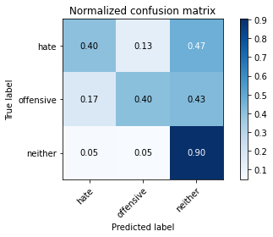

precision recall f1-score support

hate 0.62 0.40 0.49 773

offensive 0.46 0.40 0.43 430

neither 0.79 0.90 0.84 2329

accuracy 0.73 3532

macro avg 0.62 0.57 0.59 3532

weighted avg 0.72 0.73 0.72 3532

average eval_loss: 1.2228349420310414, accuracy: 0.7330124575311439

training 6 epoch...

52.845940589904785 seconds used......

6 training finished! average train loss: 0.033374172588068234

evaluating...

Confusion matrix, without normalization

[[ 347 58 368]

[ 86 148 196]

[ 131 63 2135]]

Normalized confusion matrix

[[0.44890039 0.07503234 0.47606727]

[0.2 0.34418605 0.45581395]

[0.05624732 0.02705024 0.91670245]]

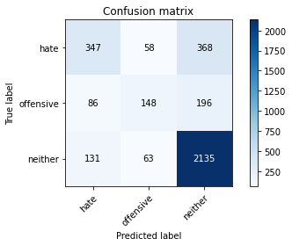

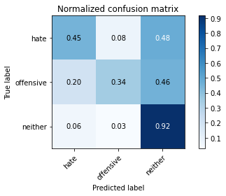

precision recall f1-score support

hate 0.62 0.45 0.52 773

offensive 0.55 0.34 0.42 430

neither 0.79 0.92 0.85 2329

accuracy 0.74 3532

macro avg 0.65 0.57 0.60 3532

weighted avg 0.72 0.74 0.73 3532

average eval_loss: 1.2987107831542775, accuracy: 0.7446206115515289

training 7 epoch...

52.70331001281738 seconds used......

7 training finished! average train loss: 0.01822778822302696

evaluating...

Confusion matrix, without normalization

[[ 238 168 367]

[ 32 213 185]

[ 76 143 2110]]

Normalized confusion matrix

[[0.30789133 0.21733506 0.47477361]

[0.0744186 0.49534884 0.43023256]

[0.03263203 0.06139974 0.90596823]]

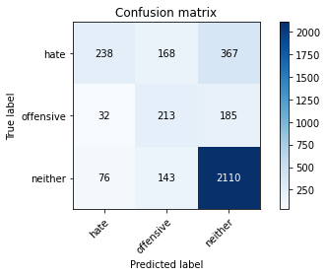

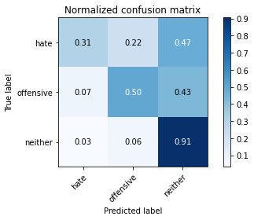

precision recall f1-score support

hate 0.69 0.31 0.43 773

offensive 0.41 0.50 0.45 430

neither 0.79 0.91 0.85 2329

accuracy 0.73 3532

macro avg 0.63 0.57 0.57 3532

weighted avg 0.72 0.73 0.70 3532

average eval_loss: 1.5285335906312965, accuracy: 0.7250849377123443

training 8 epoch...

52.71805119514465 seconds used......

8 training finished! average train loss: 0.023892623547694655

evaluating...

Confusion matrix, without normalization

[[ 401 39 333]

[ 123 114 193]

[ 176 41 2112]]

Normalized confusion matrix

[[0.51875809 0.05045278 0.43078913]

[0.28604651 0.26511628 0.44883721]

[0.07556891 0.01760412 0.90682696]]

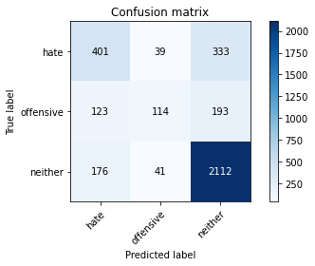

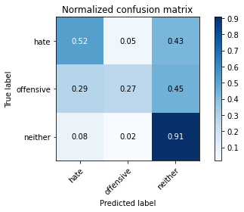

precision recall f1-score support

hate 0.57 0.52 0.54 773

offensive 0.59 0.27 0.37 430

neither 0.80 0.91 0.85 2329

accuracy 0.74 3532

macro avg 0.65 0.56 0.59 3532

weighted avg 0.72 0.74 0.72 3532

average eval_loss: 1.419710830443323, accuracy: 0.7437712344280861

training 9 epoch...

52.81020474433899 seconds used......

9 training finished! average train loss: 0.014459014563418672

evaluating...

Confusion matrix, without normalization

[[ 333 63 377]

[ 78 131 221]

[ 126 49 2154]]

Normalized confusion matrix

[[0.43078913 0.08150065 0.48771022]

[0.18139535 0.30465116 0.51395349]

[0.05410047 0.02103907 0.92486046]]

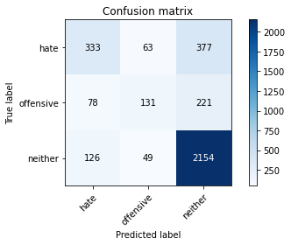

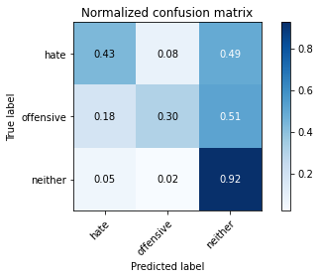

precision recall f1-score support

hate 0.62 0.43 0.51 773

offensive 0.54 0.30 0.39 430

neither 0.78 0.92 0.85 2329

accuracy 0.74 3532

macro avg 0.65 0.55 0.58 3532

weighted avg 0.72 0.74 0.72 3532

average eval_loss: 1.553372387242856, accuracy: 0.7412231030577576

training 10 epoch...

52.74538230895996 seconds used......

10 training finished! average train loss: 0.01019329849167484

evaluating...

Confusion matrix, without normalization

[[ 359 100 314]

[ 84 186 160]

[ 174 136 2019]]

Normalized confusion matrix

[[0.46442432 0.12936611 0.40620957]

[0.19534884 0.43255814 0.37209302]

[0.07471018 0.05839416 0.86689566]]

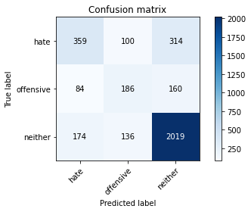

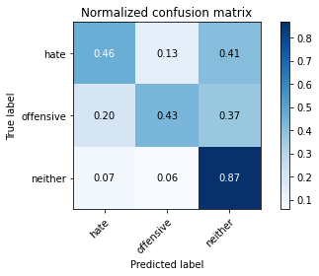

precision recall f1-score support

hate 0.58 0.46 0.52 773

offensive 0.44 0.43 0.44 430

neither 0.81 0.87 0.84 2329

accuracy 0.73 3532

macro avg 0.61 0.59 0.60 3532

weighted avg 0.72 0.73 0.72 3532

average eval_loss: 1.5103270195971774, accuracy: 0.7259343148357871

2 run......

training 1 epoch...

52.709563970565796 seconds used......

1 training finished! average train loss: 0.729484273974164

evaluating...

Confusion matrix, without normalization

[[ 197 39 537]

[ 43 92 295]

[ 47 32 2250]]

Normalized confusion matrix

[[0.25485123 0.05045278 0.69469599]

[0.1 0.21395349 0.68604651]

[0.02018033 0.0137398 0.96607986]]

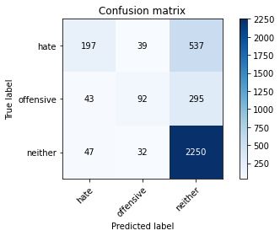

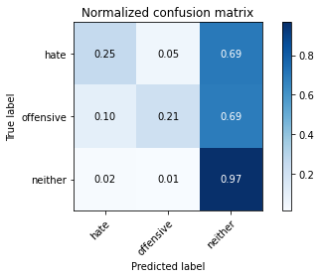

precision recall f1-score support

hate 0.69 0.25 0.37 773

offensive 0.56 0.21 0.31 430

neither 0.73 0.97 0.83 2329

accuracy 0.72 3532

macro avg 0.66 0.48 0.50 3532

weighted avg 0.70 0.72 0.67 3532

average eval_loss: 0.6997186903562923, accuracy: 0.7188561721404304

training 2 epoch...

52.713932037353516 seconds used......

2 training finished! average train loss: 0.5053796717726377

evaluating...

Confusion matrix, without normalization

[[ 316 98 359]

[ 71 156 203]

[ 130 72 2127]]

Normalized confusion matrix

[[0.4087969 0.12677878 0.46442432]

[0.16511628 0.3627907 0.47209302]

[0.05581795 0.03091456 0.9132675 ]]

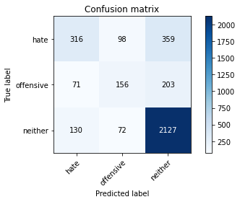

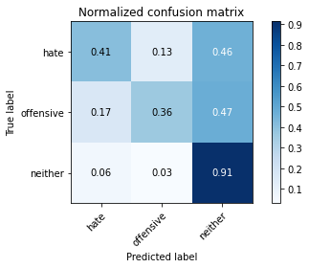

precision recall f1-score support

hate 0.61 0.41 0.49 773

offensive 0.48 0.36 0.41 430

neither 0.79 0.91 0.85 2329

accuracy 0.74 3532

macro avg 0.63 0.56 0.58 3532

weighted avg 0.71 0.74 0.72 3532

average eval_loss: 0.6565447460628498, accuracy: 0.7358437146092865

training 3 epoch...

52.683396100997925 seconds used......

3 training finished! average train loss: 0.32430732394179024

evaluating...

Confusion matrix, without normalization

[[ 397 40 336]

[ 121 132 177]

[ 180 57 2092]]

Normalized confusion matrix

[[0.51358344 0.05174644 0.43467012]

[0.28139535 0.30697674 0.41162791]

[0.07728639 0.02447402 0.89823959]]

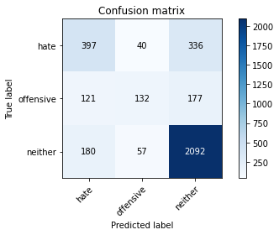

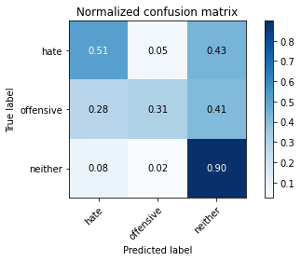

precision recall f1-score support

hate 0.57 0.51 0.54 773

offensive 0.58 0.31 0.40 430

neither 0.80 0.90 0.85 2329

accuracy 0.74 3532

macro avg 0.65 0.57 0.60 3532

weighted avg 0.72 0.74 0.73 3532

average eval_loss: 0.7523979113600349, accuracy: 0.7420724801812004

training 4 epoch...

52.74002194404602 seconds used......

4 training finished! average train loss: 0.1511645817320304

evaluating...

Confusion matrix, without normalization

[[ 245 123 405]

[ 33 178 219]

[ 67 97 2165]]

Normalized confusion matrix

[[0.31694696 0.15912031 0.52393273]

[0.07674419 0.41395349 0.50930233]

[0.02876771 0.04164878 0.92958351]]

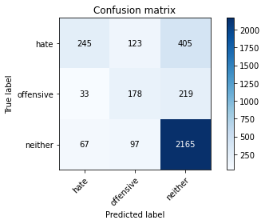

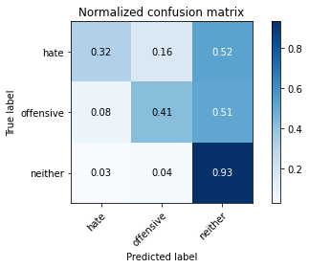

precision recall f1-score support

hate 0.71 0.32 0.44 773

offensive 0.45 0.41 0.43 430

neither 0.78 0.93 0.85 2329

accuracy 0.73 3532

macro avg 0.64 0.55 0.57 3532

weighted avg 0.72 0.73 0.71 3532

average eval_loss: 1.0461588727131401, accuracy: 0.7327293318233296

training 5 epoch...

52.75919198989868 seconds used......

5 training finished! average train loss: 0.062268908840578154

evaluating...

Confusion matrix, without normalization

[[ 347 125 301]

[ 77 202 151]

[ 189 165 1975]]

Normalized confusion matrix

[[0.44890039 0.16170763 0.38939198]

[0.17906977 0.46976744 0.35116279]

[0.08115071 0.07084586 0.84800343]]

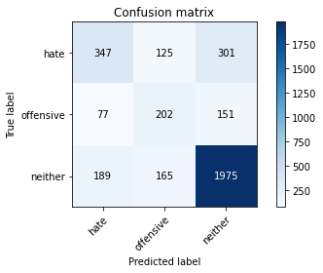

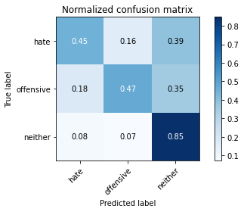

precision recall f1-score support

hate 0.57 0.45 0.50 773

offensive 0.41 0.47 0.44 430

neither 0.81 0.85 0.83 2329

accuracy 0.71 3532

macro avg 0.60 0.59 0.59 3532

weighted avg 0.71 0.71 0.71 3532

average eval_loss: 1.1756631588868502, accuracy: 0.7146092865232163

training 6 epoch...

52.689114570617676 seconds used......

6 training finished! average train loss: 0.027520458547229624

evaluating...

Confusion matrix, without normalization

[[ 326 61 386]

[ 73 151 206]

[ 122 71 2136]]

Normalized confusion matrix

[[0.42173351 0.07891332 0.49935317]

[0.16976744 0.35116279 0.47906977]

[0.052383 0.03048519 0.91713182]]

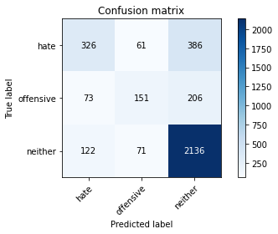

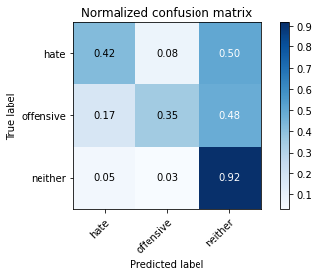

precision recall f1-score support

hate 0.63 0.42 0.50 773

offensive 0.53 0.35 0.42 430

neither 0.78 0.92 0.84 2329

accuracy 0.74 3532

macro avg 0.65 0.56 0.59 3532

weighted avg 0.72 0.74 0.72 3532

average eval_loss: 1.3639881390089033, accuracy: 0.7398074745186863

training 7 epoch...

52.74754595756531 seconds used......

7 training finished! average train loss: 0.016692751575404206

evaluating...

Confusion matrix, without normalization

[[ 444 27 302]

[ 154 86 190]

[ 263 33 2033]]

Normalized confusion matrix

[[0.57438551 0.03492885 0.39068564]

[0.35813953 0.2 0.44186047]

[0.112924 0.01416917 0.87290683]]

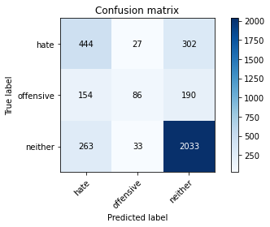

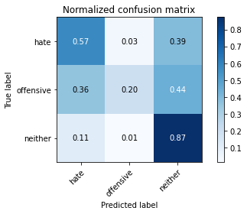

precision recall f1-score support

hate 0.52 0.57 0.54 773

offensive 0.59 0.20 0.30 430

neither 0.81 0.87 0.84 2329

accuracy 0.73 3532

macro avg 0.64 0.55 0.56 3532

weighted avg 0.72 0.73 0.71 3532

average eval_loss: 1.4543602456743856, accuracy: 0.7256511891279728

training 8 epoch...

52.6936354637146 seconds used......

8 training finished! average train loss: 0.022014359666444584

evaluating...

Confusion matrix, without normalization

[[ 451 34 288]

[ 133 139 158]

[ 258 76 1995]]

Normalized confusion matrix

[[0.58344114 0.04398448 0.37257439]

[0.30930233 0.32325581 0.36744186]

[0.11077716 0.03263203 0.85659081]]

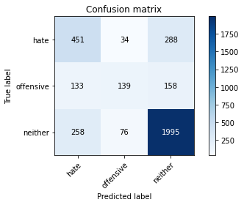

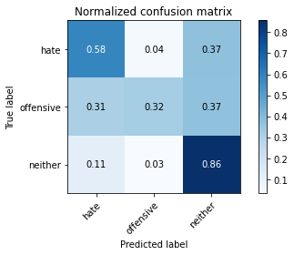

precision recall f1-score support

hate 0.54 0.58 0.56 773

offensive 0.56 0.32 0.41 430

neither 0.82 0.86 0.84 2329

accuracy 0.73 3532

macro avg 0.64 0.59 0.60 3532

weighted avg 0.72 0.73 0.72 3532

average eval_loss: 1.4273324891146124, accuracy: 0.7318799546998868

training 9 epoch...

52.76197028160095 seconds used......

9 training finished! average train loss: 0.011211008859767701

evaluating...

Confusion matrix, without normalization

[[ 295 89 389]

[ 52 153 225]

[ 115 76 2138]]

Normalized confusion matrix

[[0.38163001 0.11513583 0.50323415]

[0.12093023 0.35581395 0.52325581]

[0.04937742 0.03263203 0.91799055]]

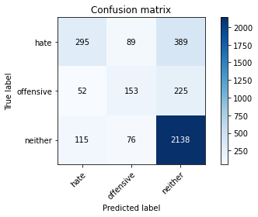

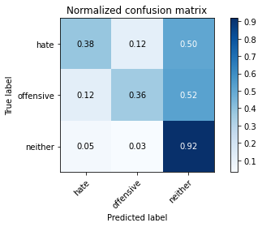

precision recall f1-score support

hate 0.64 0.38 0.48 773

offensive 0.48 0.36 0.41 430

neither 0.78 0.92 0.84 2329

accuracy 0.73 3532

macro avg 0.63 0.55 0.58 3532

weighted avg 0.71 0.73 0.71 3532

average eval_loss: 1.6046920527551471, accuracy: 0.7321630804077011

training 10 epoch...

52.71698975563049 seconds used......

10 training finished! average train loss: 0.016835499672911154

evaluating...

Confusion matrix, without normalization

[[ 388 63 322]

[ 102 152 176]

[ 204 104 2021]]

Normalized confusion matrix

[[0.50194049 0.08150065 0.41655886]

[0.2372093 0.35348837 0.40930233]

[0.08759124 0.04465436 0.8677544 ]]

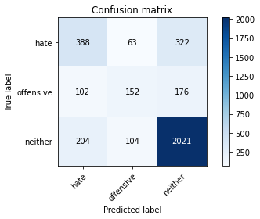

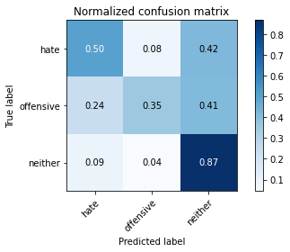

precision recall f1-score support

hate 0.56 0.50 0.53 773

offensive 0.48 0.35 0.41 430

neither 0.80 0.87 0.83 2329

accuracy 0.73 3532

macro avg 0.61 0.57 0.59 3532

weighted avg 0.71 0.73 0.71 3532

average eval_loss: 1.4727529007625781, accuracy: 0.7250849377123443

3 run......

training 1 epoch...

52.68442964553833 seconds used......

1 training finished! average train loss: 0.7201612704541104

evaluating...

Confusion matrix, without normalization

[[ 272 32 469]

[ 66 81 283]

[ 81 23 2225]]

Normalized confusion matrix

[[0.35187581 0.04139715 0.60672704]

[0.15348837 0.18837209 0.65813953]

[0.03477888 0.00987548 0.95534564]]

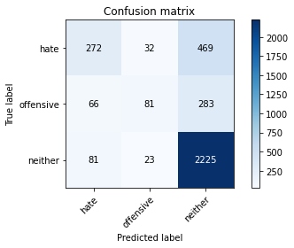

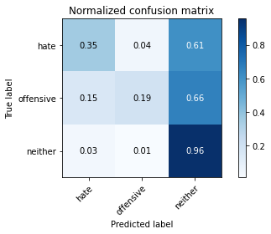

precision recall f1-score support

hate 0.65 0.35 0.46 773

offensive 0.60 0.19 0.29 430

neither 0.75 0.96 0.84 2329

accuracy 0.73 3532

macro avg 0.66 0.50 0.53 3532

weighted avg 0.71 0.73 0.69 3532

average eval_loss: 0.6822259759498854, accuracy: 0.7298980747451869

training 2 epoch...

52.796233892440796 seconds used......

2 training finished! average train loss: 0.4913069217417582

evaluating...

Confusion matrix, without normalization

[[ 360 75 338]

[ 72 142 216]

[ 145 85 2099]]

Normalized confusion matrix

[[0.46571798 0.09702458 0.43725744]

[0.16744186 0.33023256 0.50232558]

[0.06225848 0.03649635 0.90124517]]

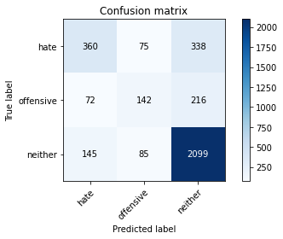

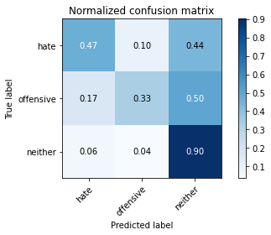

precision recall f1-score support

hate 0.62 0.47 0.53 773

offensive 0.47 0.33 0.39 430

neither 0.79 0.90 0.84 2329

accuracy 0.74 3532

macro avg 0.63 0.57 0.59 3532

weighted avg 0.72 0.74 0.72 3532

average eval_loss: 0.6705751692676275, accuracy: 0.736409966024915

training 3 epoch...

52.9749219417572 seconds used......

3 training finished! average train loss: 0.30129358975357745

evaluating...

Confusion matrix, without normalization

[[ 312 100 361]

[ 53 183 194]

[ 139 102 2088]]

Normalized confusion matrix

[[0.40362225 0.12936611 0.46701164]

[0.12325581 0.4255814 0.45116279]

[0.05968227 0.04379562 0.89652211]]

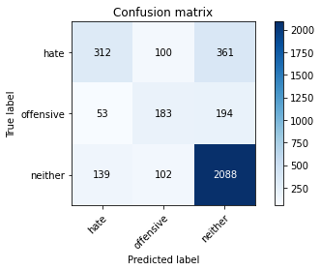

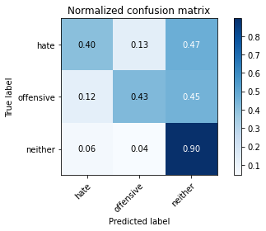

precision recall f1-score support

hate 0.62 0.40 0.49 773

offensive 0.48 0.43 0.45 430

neither 0.79 0.90 0.84 2329

accuracy 0.73 3532

macro avg 0.63 0.58 0.59 3532

weighted avg 0.71 0.73 0.72 3532

average eval_loss: 0.7734642486787785, accuracy: 0.7313137032842583

training 4 epoch...

52.969871520996094 seconds used......

4 training finished! average train loss: 0.13590219660302202

evaluating...

Confusion matrix, without normalization

[[ 251 126 396]

[ 36 169 225]

[ 95 106 2128]]

Normalized confusion matrix

[[0.32470893 0.16300129 0.51228978]

[0.08372093 0.39302326 0.52325581]

[0.04079004 0.0455131 0.91369687]]

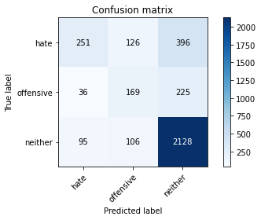

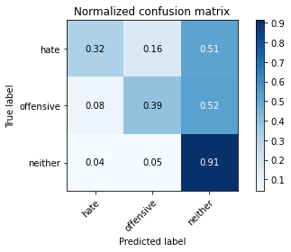

precision recall f1-score support

hate 0.66 0.32 0.43 773

offensive 0.42 0.39 0.41 430

neither 0.77 0.91 0.84 2329

accuracy 0.72 3532

macro avg 0.62 0.54 0.56 3532

weighted avg 0.71 0.72 0.70 3532

average eval_loss: 1.092343262865045, accuracy: 0.7214043035107588

training 5 epoch...

52.94590187072754 seconds used......

5 training finished! average train loss: 0.064348916373813

evaluating...

Confusion matrix, without normalization

[[ 364 71 338]

[ 85 173 172]

[ 160 95 2074]]

Normalized confusion matrix

[[0.47089263 0.09184994 0.43725744]

[0.19767442 0.40232558 0.4 ]

[0.06869901 0.04079004 0.89051095]]

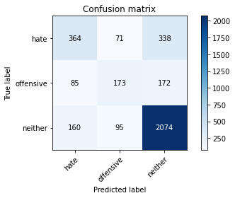

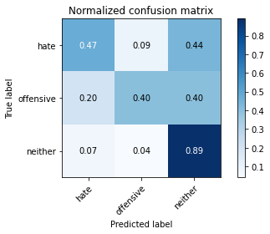

precision recall f1-score support

hate 0.60 0.47 0.53 773

offensive 0.51 0.40 0.45 430

neither 0.80 0.89 0.84 2329

accuracy 0.74 3532

macro avg 0.64 0.59 0.61 3532

weighted avg 0.72 0.74 0.73 3532

average eval_loss: 1.15628273667252, accuracy: 0.7392412231030577

training 6 epoch...

53.00143885612488 seconds used......

6 training finished! average train loss: 0.03577727871062048

evaluating...

Confusion matrix, without normalization

[[ 311 74 388]

[ 65 129 236]

[ 114 58 2157]]

Normalized confusion matrix

[[0.40232859 0.09573092 0.50194049]

[0.15116279 0.3 0.54883721]

[0.04894805 0.02490339 0.92614856]]

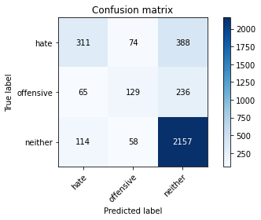

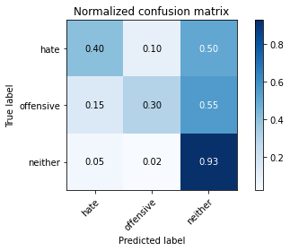

precision recall f1-score support

hate 0.63 0.40 0.49 773

offensive 0.49 0.30 0.37 430

neither 0.78 0.93 0.84 2329

accuracy 0.74 3532

macro avg 0.63 0.54 0.57 3532

weighted avg 0.71 0.74 0.71 3532

average eval_loss: 1.398328783400988, accuracy: 0.7352774631936579

training 7 epoch...

52.953810691833496 seconds used......

7 training finished! average train loss: 0.023138418073387467

evaluating...

Confusion matrix, without normalization

[[ 371 55 347]

[ 102 134 194]

[ 177 75 2077]]

Normalized confusion matrix

[[0.47994825 0.07115136 0.44890039]

[0.2372093 0.31162791 0.45116279]

[0.07599828 0.03220266 0.89179906]]

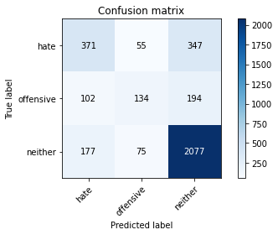

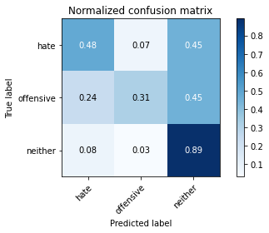

precision recall f1-score support

hate 0.57 0.48 0.52 773

offensive 0.51 0.31 0.39 430

neither 0.79 0.89 0.84 2329

accuracy 0.73 3532

macro avg 0.62 0.56 0.58 3532

weighted avg 0.71 0.73 0.71 3532

average eval_loss: 1.4280637755232342, accuracy: 0.731030577576444

training 8 epoch...

52.98997402191162 seconds used......

8 training finished! average train loss: 0.013261087339550472

evaluating...

Confusion matrix, without normalization

[[ 280 75 418]

[ 53 127 250]

[ 95 66 2168]]

Normalized confusion matrix

[[0.3622251 0.09702458 0.54075032]

[0.12325581 0.29534884 0.58139535]

[0.04079004 0.02833834 0.93087162]]

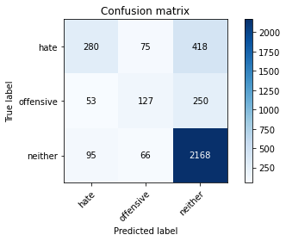

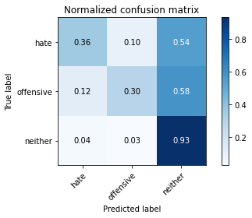

precision recall f1-score support

hate 0.65 0.36 0.47 773

offensive 0.47 0.30 0.36 430

neither 0.76 0.93 0.84 2329

accuracy 0.73 3532

macro avg 0.63 0.53 0.56 3532

weighted avg 0.70 0.73 0.70 3532

average eval_loss: 1.663852624637259, accuracy: 0.7290486976217441

training 9 epoch...

52.922863721847534 seconds used......

9 training finished! average train loss: 0.011286656988647384

evaluating...

Confusion matrix, without normalization

[[ 424 31 318]

[ 134 107 189]

[ 227 46 2056]]

Normalized confusion matrix

[[0.54851229 0.04010349 0.41138422]

[0.31162791 0.24883721 0.43953488]

[0.09746672 0.01975097 0.88278231]]

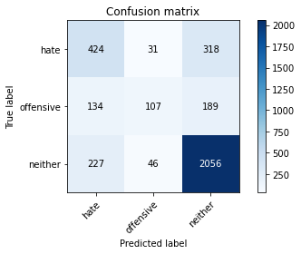

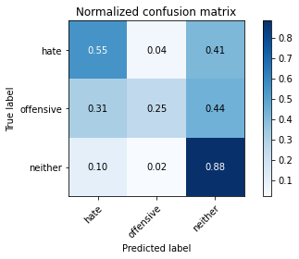

precision recall f1-score support

hate 0.54 0.55 0.54 773

offensive 0.58 0.25 0.35 430

neither 0.80 0.88 0.84 2329

accuracy 0.73 3532

macro avg 0.64 0.56 0.58 3532

weighted avg 0.72 0.73 0.72 3532

average eval_loss: 1.596832919423863, accuracy: 0.7324462061155153

training 10 epoch...

52.91871881484985 seconds used......

10 training finished! average train loss: 0.011836011480100349

evaluating...

Confusion matrix, without normalization

[[ 228 69 476]

[ 37 118 275]

[ 65 44 2220]]

Normalized confusion matrix

[[0.29495472 0.08926261 0.61578266]

[0.08604651 0.2744186 0.63953488]

[0.02790897 0.01889223 0.9531988 ]]

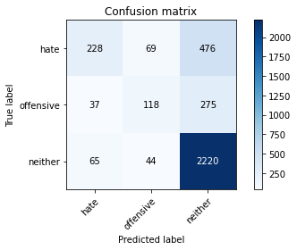

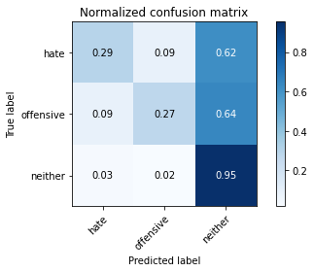

precision recall f1-score support

hate 0.69 0.29 0.41 773

offensive 0.51 0.27 0.36 430

neither 0.75 0.95 0.84 2329

accuracy 0.73 3532

macro avg 0.65 0.51 0.54 3532

weighted avg 0.71 0.73 0.69 3532

average eval_loss: 1.8885344393172507, accuracy: 0.7265005662514157

4 run......

training 1 epoch...

52.903000593185425 seconds used......

1 training finished! average train loss: 0.7384359309397845

evaluating...

Confusion matrix, without normalization

[[ 425 5 343]

[ 163 26 241]

[ 250 8 2071]]

Normalized confusion matrix

[[0.54980595 0.00646831 0.44372574]

[0.37906977 0.06046512 0.56046512]

[0.10734221 0.00343495 0.88922284]]

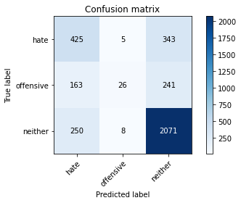

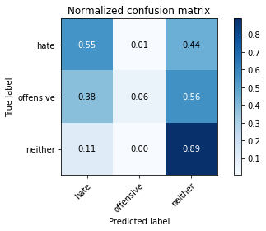

precision recall f1-score support

hate 0.51 0.55 0.53 773

offensive 0.67 0.06 0.11 430

neither 0.78 0.89 0.83 2329

accuracy 0.71 3532

macro avg 0.65 0.50 0.49 3532

weighted avg 0.71 0.71 0.68 3532

average eval_loss: 0.6835542334675115, accuracy: 0.7140430351075878

training 2 epoch...

52.88571286201477 seconds used......

2 training finished! average train loss: 0.496059826942554

evaluating...

Confusion matrix, without normalization

[[ 282 78 413]

[ 59 142 229]

[ 83 72 2174]]

Normalized confusion matrix

[[0.36481242 0.10090556 0.53428202]

[0.1372093 0.33023256 0.53255814]

[0.03563761 0.03091456 0.93344783]]

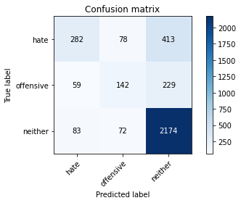

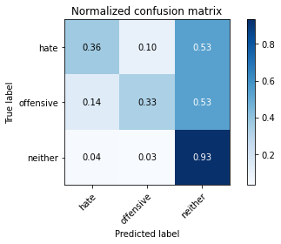

precision recall f1-score support

hate 0.67 0.36 0.47 773

offensive 0.49 0.33 0.39 430

neither 0.77 0.93 0.85 2329

accuracy 0.74 3532

macro avg 0.64 0.54 0.57 3532

weighted avg 0.71 0.74 0.71 3532

average eval_loss: 0.6930967887579385, accuracy: 0.7355605889014722

training 3 epoch...

52.964638471603394 seconds used......

3 training finished! average train loss: 0.30916373884357307

evaluating...

Confusion matrix, without normalization

[[ 264 78 431]

[ 52 121 257]

[ 83 62 2184]]

Normalized confusion matrix

[[0.34152652 0.10090556 0.55756792]

[0.12093023 0.28139535 0.59767442]

[0.03563761 0.02662087 0.93774152]]

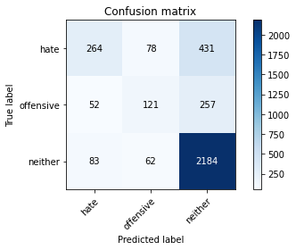

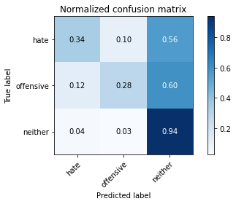

precision recall f1-score support

hate 0.66 0.34 0.45 773

offensive 0.46 0.28 0.35 430

neither 0.76 0.94 0.84 2329

accuracy 0.73 3532

macro avg 0.63 0.52 0.55 3532

weighted avg 0.70 0.73 0.70 3532

average eval_loss: 0.9075701490128781, accuracy: 0.7273499433748585

training 4 epoch...

52.85568571090698 seconds used......

4 training finished! average train loss: 0.14484391903571517

evaluating...

Confusion matrix, without normalization

[[ 351 32 390]

[ 109 86 235]

[ 164 35 2130]]

Normalized confusion matrix

[[0.45407503 0.04139715 0.50452781]

[0.25348837 0.2 0.54651163]

[0.07041649 0.01502791 0.9145556 ]]

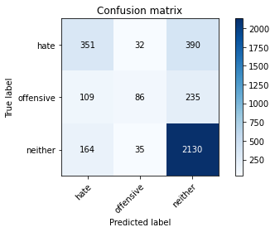

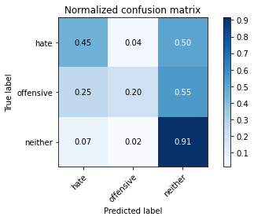

precision recall f1-score support

hate 0.56 0.45 0.50 773

offensive 0.56 0.20 0.30 430

neither 0.77 0.91 0.84 2329

accuracy 0.73 3532

macro avg 0.63 0.52 0.55 3532

weighted avg 0.70 0.73 0.70 3532

average eval_loss: 1.1151721218211503, accuracy: 0.7267836919592299

training 5 epoch...

52.87243390083313 seconds used......

5 training finished! average train loss: 0.054075879736829445

evaluating...

Confusion matrix, without normalization

[[ 266 63 444]

[ 49 97 284]

[ 87 48 2194]]

Normalized confusion matrix

[[0.34411384 0.08150065 0.57438551]

[0.11395349 0.2255814 0.66046512]

[0.03735509 0.0206097 0.94203521]]

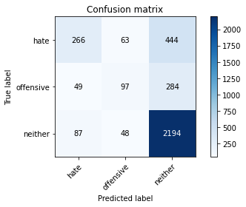

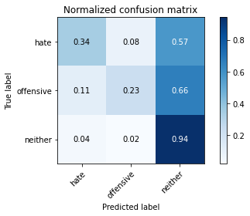

precision recall f1-score support

hate 0.66 0.34 0.45 773

offensive 0.47 0.23 0.30 430

neither 0.75 0.94 0.84 2329

accuracy 0.72 3532

macro avg 0.63 0.50 0.53 3532

weighted avg 0.70 0.72 0.69 3532

average eval_loss: 1.446927601334739, accuracy: 0.7239524348810872

training 6 epoch...

52.93675780296326 seconds used......

6 training finished! average train loss: 0.033235497105740516

evaluating...

Confusion matrix, without normalization

[[ 341 95 337]

[ 78 152 200]

[ 160 98 2071]]

Normalized confusion matrix

[[0.44113842 0.1228978 0.43596378]

[0.18139535 0.35348837 0.46511628]

[0.06869901 0.04207815 0.88922284]]

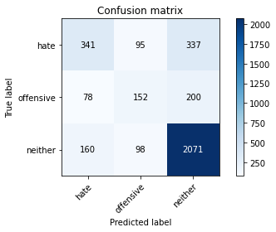

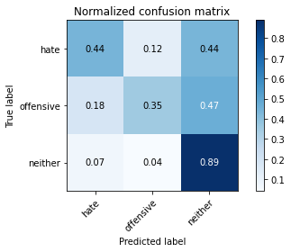

precision recall f1-score support

hate 0.59 0.44 0.50 773

offensive 0.44 0.35 0.39 430

neither 0.79 0.89 0.84 2329

accuracy 0.73 3532

macro avg 0.61 0.56 0.58 3532

weighted avg 0.71 0.73 0.71 3532

average eval_loss: 1.3589451343326244, accuracy: 0.7259343148357871

training 7 epoch...

52.895307779312134 seconds used......

7 training finished! average train loss: 0.02436910783227318

evaluating...

Confusion matrix, without normalization

[[ 274 92 407]

[ 55 154 221]

[ 105 102 2122]]

Normalized confusion matrix

[[0.35446313 0.11901682 0.52652005]

[0.12790698 0.35813953 0.51395349]

[0.04508373 0.04379562 0.91112065]]

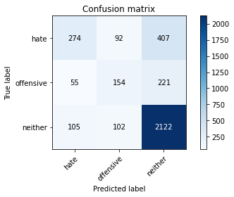

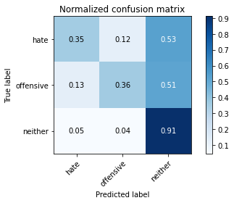

precision recall f1-score support

hate 0.63 0.35 0.45 773

offensive 0.44 0.36 0.40 430

neither 0.77 0.91 0.84 2329

accuracy 0.72 3532

macro avg 0.62 0.54 0.56 3532

weighted avg 0.70 0.72 0.70 3532

average eval_loss: 1.5660705386245317, accuracy: 0.7219705549263873

training 8 epoch...

52.94389343261719 seconds used......

8 training finished! average train loss: 0.015311218697282735

evaluating...

Confusion matrix, without normalization

[[ 281 103 389]

[ 50 155 225]

[ 99 78 2152]]

Normalized confusion matrix

[[0.36351876 0.13324709 0.50323415]

[0.11627907 0.36046512 0.52325581]

[0.04250751 0.03349077 0.92400172]]

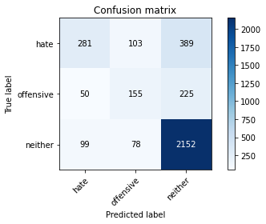

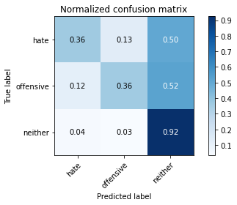

precision recall f1-score support

hate 0.65 0.36 0.47 773

offensive 0.46 0.36 0.40 430

neither 0.78 0.92 0.84 2329

accuracy 0.73 3532

macro avg 0.63 0.55 0.57 3532

weighted avg 0.71 0.73 0.71 3532

average eval_loss: 1.611440590040832, accuracy: 0.7327293318233296

training 9 epoch...

52.90762662887573 seconds used......

9 training finished! average train loss: 0.016474461656266013

evaluating...

Confusion matrix, without normalization

[[ 336 76 361]

[ 77 136 217]

[ 145 81 2103]]

Normalized confusion matrix

[[0.43467012 0.09831824 0.46701164]

[0.17906977 0.31627907 0.50465116]

[0.06225848 0.03477888 0.90296264]]

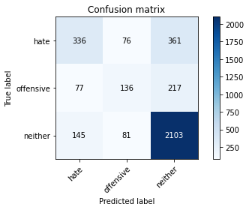

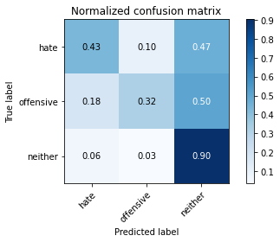

precision recall f1-score support

hate 0.60 0.43 0.50 773

offensive 0.46 0.32 0.38 430

neither 0.78 0.90 0.84 2329

accuracy 0.73 3532

macro avg 0.62 0.55 0.57 3532

weighted avg 0.71 0.73 0.71 3532

average eval_loss: 1.6193221126614654, accuracy: 0.7290486976217441

training 10 epoch...

52.94510078430176 seconds used......

10 training finished! average train loss: 0.015310536654639629

evaluating...

Confusion matrix, without normalization

[[ 332 92 349]

[ 83 143 204]

[ 167 95 2067]]

Normalized confusion matrix

[[0.42949547 0.11901682 0.45148771]

[0.19302326 0.33255814 0.4744186 ]

[0.07170459 0.04079004 0.88750537]]

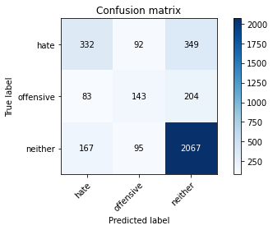

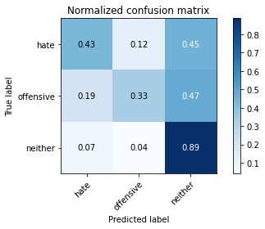

precision recall f1-score support

hate 0.57 0.43 0.49 773

offensive 0.43 0.33 0.38 430

neither 0.79 0.89 0.84 2329

accuracy 0.72 3532

macro avg 0.60 0.55 0.57 3532

weighted avg 0.70 0.72 0.70 3532

average eval_loss: 1.576666688136125, accuracy: 0.7197055492638732

5 run......

training 1 epoch...

52.88335418701172 seconds used......

1 training finished! average train loss: 0.7440741780507137

evaluating...

Confusion matrix, without normalization

[[ 239 47 487]

[ 56 77 297]

[ 78 22 2229]]

Normalized confusion matrix

[[0.30918499 0.06080207 0.63001294]

[0.13023256 0.17906977 0.69069767]

[0.03349077 0.00944611 0.95706312]]

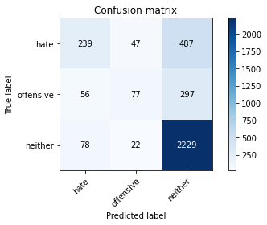

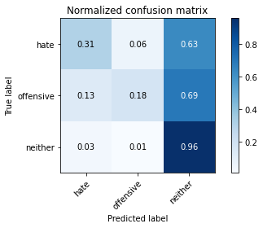

precision recall f1-score support

hate 0.64 0.31 0.42 773

offensive 0.53 0.18 0.27 430

neither 0.74 0.96 0.83 2329

accuracy 0.72 3532

macro avg 0.64 0.48 0.51 3532

weighted avg 0.69 0.72 0.67 3532

average eval_loss: 0.7010038905056183, accuracy: 0.720554926387316

training 2 epoch...

52.96855664253235 seconds used......

2 training finished! average train loss: 0.4918714492800701

evaluating...

Confusion matrix, without normalization

[[ 280 38 455]

[ 56 97 277]

[ 73 24 2232]]

Normalized confusion matrix

[[0.3622251 0.04915912 0.58861578]

[0.13023256 0.2255814 0.64418605]

[0.03134392 0.01030485 0.95835122]]

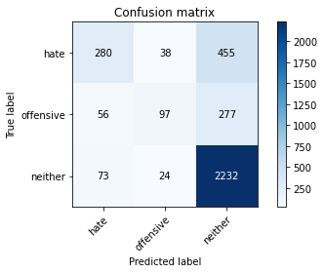

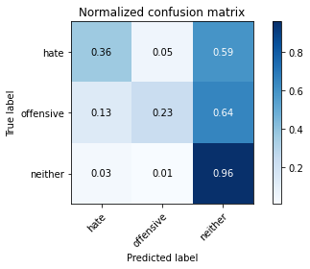

precision recall f1-score support

hate 0.68 0.36 0.47 773

offensive 0.61 0.23 0.33 430

neither 0.75 0.96 0.84 2329

accuracy 0.74 3532

macro avg 0.68 0.52 0.55 3532

weighted avg 0.72 0.74 0.70 3532

average eval_loss: 0.7415784302741121, accuracy: 0.7386749716874292

training 3 epoch...

52.92808437347412 seconds used......

3 training finished! average train loss: 0.2969516071220081

evaluating...

Confusion matrix, without normalization

[[ 175 126 472]

[ 14 164 252]

[ 38 77 2214]]

Normalized confusion matrix

[[0.22639069 0.16300129 0.61060802]

[0.03255814 0.38139535 0.58604651]

[0.01631602 0.0330614 0.95062258]]

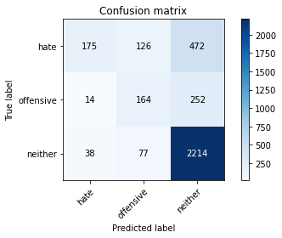

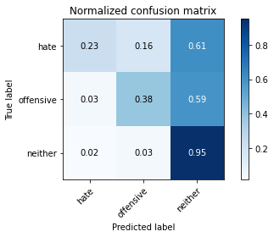

precision recall f1-score support

hate 0.77 0.23 0.35 773

offensive 0.45 0.38 0.41 430

neither 0.75 0.95 0.84 2329

accuracy 0.72 3532

macro avg 0.66 0.52 0.53 3532

weighted avg 0.72 0.72 0.68 3532

average eval_loss: 0.9694197359731642, accuracy: 0.7228199320498301

training 4 epoch...

53.019214153289795 seconds used......

4 training finished! average train loss: 0.13553829753838212

evaluating...

Confusion matrix, without normalization

[[ 457 38 278]

[ 161 111 158]

[ 285 67 1977]]

Normalized confusion matrix

[[0.5912031 0.04915912 0.35963777]

[0.3744186 0.25813953 0.36744186]

[0.12237012 0.02876771 0.84886217]]

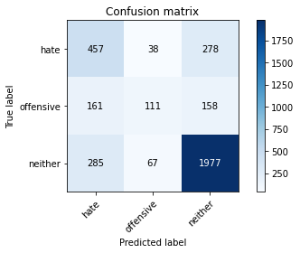

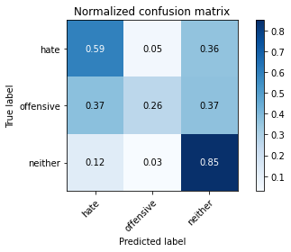

precision recall f1-score support

hate 0.51 0.59 0.55 773

offensive 0.51 0.26 0.34 430

neither 0.82 0.85 0.83 2329

accuracy 0.72 3532

macro avg 0.61 0.57 0.57 3532

weighted avg 0.71 0.72 0.71 3532

average eval_loss: 0.9596936899726674, accuracy: 0.720554926387316

training 5 epoch...

52.89367628097534 seconds used......

5 training finished! average train loss: 0.055349783220539885

evaluating...

Confusion matrix, without normalization

[[ 379 82 312]

[ 88 167 175]

[ 170 120 2039]]

Normalized confusion matrix

[[0.49029754 0.10608021 0.40362225]

[0.20465116 0.38837209 0.40697674]

[0.0729927 0.05152426 0.87548304]]

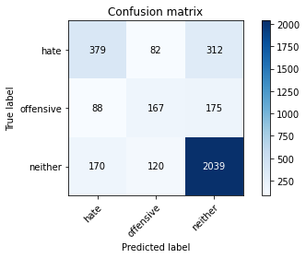

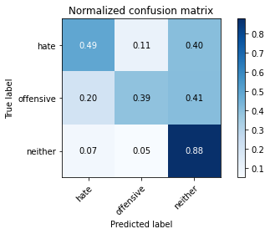

precision recall f1-score support

hate 0.59 0.49 0.54 773

offensive 0.45 0.39 0.42 430

neither 0.81 0.88 0.84 2329

accuracy 0.73 3532

macro avg 0.62 0.58 0.60 3532

weighted avg 0.72 0.73 0.72 3532

average eval_loss: 1.1878154981186835, accuracy: 0.7318799546998868

training 6 epoch...

52.94934129714966 seconds used......

6 training finished! average train loss: 0.02276568479888861

evaluating...

Confusion matrix, without normalization

[[ 389 36 348]

[ 120 110 200]

[ 172 71 2086]]

Normalized confusion matrix

[[0.50323415 0.0465718 0.45019405]

[0.27906977 0.25581395 0.46511628]

[0.07385144 0.03048519 0.89566337]]

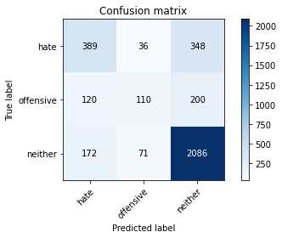

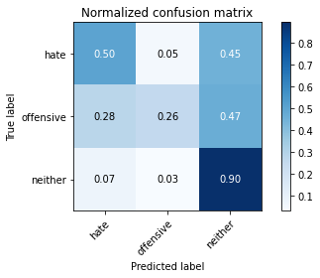

precision recall f1-score support

hate 0.57 0.50 0.54 773

offensive 0.51 0.26 0.34 430

neither 0.79 0.90 0.84 2329

accuracy 0.73 3532

macro avg 0.62 0.55 0.57 3532

weighted avg 0.71 0.73 0.71 3532

average eval_loss: 1.3866549437749858, accuracy: 0.7318799546998868

training 7 epoch...

52.97604179382324 seconds used......

7 training finished! average train loss: 0.021002955518828043

evaluating...

Confusion matrix, without normalization

[[ 292 93 388]

[ 64 152 214]

[ 108 90 2131]]

Normalized confusion matrix

[[0.37774903 0.12031048 0.50194049]

[0.14883721 0.35348837 0.49767442]

[0.04637183 0.03864319 0.91498497]]

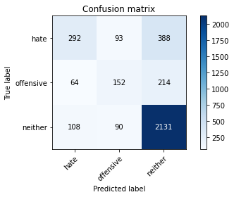

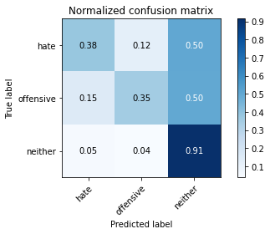

precision recall f1-score support

hate 0.63 0.38 0.47 773

offensive 0.45 0.35 0.40 430

neither 0.78 0.91 0.84 2329

accuracy 0.73 3532

macro avg 0.62 0.55 0.57 3532

weighted avg 0.71 0.73 0.71 3532

average eval_loss: 1.5325478179390821, accuracy: 0.7290486976217441

training 8 epoch...

52.95355486869812 seconds used......

8 training finished! average train loss: 0.021425009148211157

evaluating...

Confusion matrix, without normalization

[[ 259 80 434]

[ 57 147 226]

[ 68 87 2174]]

Normalized confusion matrix

[[0.33505821 0.10349288 0.5614489 ]

[0.13255814 0.34186047 0.5255814 ]

[0.02919708 0.03735509 0.93344783]]

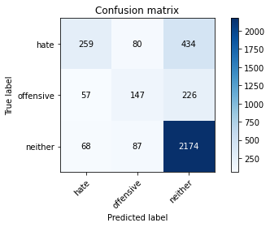

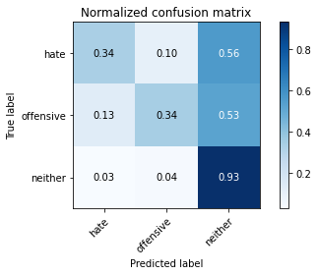

precision recall f1-score support

hate 0.67 0.34 0.45 773

offensive 0.47 0.34 0.40 430

neither 0.77 0.93 0.84 2329

accuracy 0.73 3532

macro avg 0.64 0.54 0.56 3532

weighted avg 0.71 0.73 0.70 3532

average eval_loss: 1.549524021266544, accuracy: 0.7304643261608154

training 9 epoch...

52.902504682540894 seconds used......

9 training finished! average train loss: 0.017077680899338626

evaluating...

Confusion matrix, without normalization

[[ 402 89 282]

[ 108 157 165]

[ 219 125 1985]]

Normalized confusion matrix

[[0.52005175 0.11513583 0.36481242]

[0.25116279 0.36511628 0.38372093]

[0.09403177 0.0536711 0.85229712]]

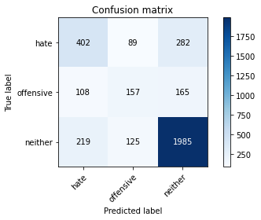

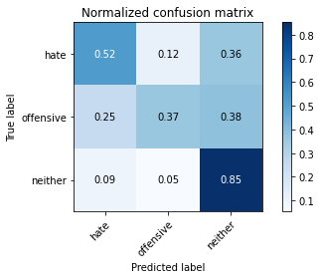

precision recall f1-score support

hate 0.55 0.52 0.54 773

offensive 0.42 0.37 0.39 430

neither 0.82 0.85 0.83 2329

accuracy 0.72 3532

macro avg 0.60 0.58 0.59 3532

weighted avg 0.71 0.72 0.71 3532

average eval_loss: 1.4936055551140994, accuracy: 0.7202718006795017

training 10 epoch...

52.886476278305054 seconds used......

10 training finished! average train loss: 0.01747064303643389

evaluating...

Confusion matrix, without normalization

[[ 376 58 339]

[ 95 137 198]

[ 166 80 2083]]

Normalized confusion matrix

[[0.48641656 0.07503234 0.4385511 ]

[0.22093023 0.31860465 0.46046512]

[0.07127523 0.03434951 0.89437527]]

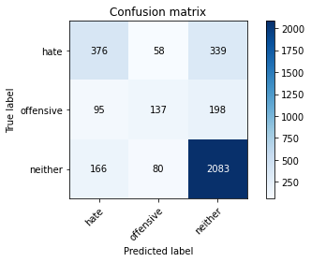

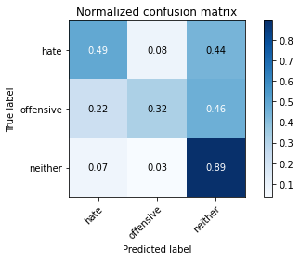

precision recall f1-score support

hate 0.59 0.49 0.53 773

offensive 0.50 0.32 0.39 430

neither 0.80 0.89 0.84 2329

accuracy 0.73 3532

macro avg 0.63 0.57 0.59 3532

weighted avg 0.71 0.73 0.72 3532

average eval_loss: 1.5003353485279838, accuracy: 0.7349943374858438